Open a browser and navigate to https://pittforms.tfaforms.net/f/myvaccinecard on your Windows, iOS, or Android device.
Authenticate to Pitt Passport by typing in your Pitt username and your password.
Select Submit.
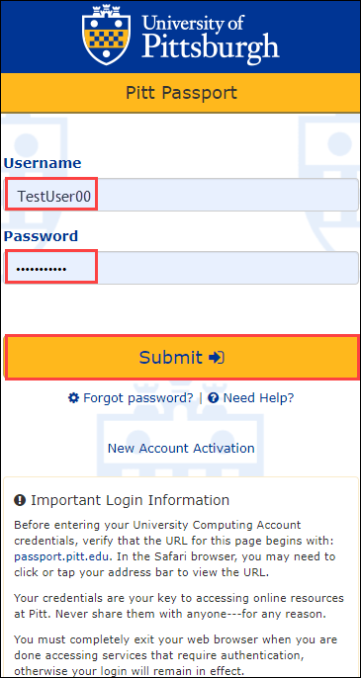

Authenticate using the multi-factor authentication method of your choice. If you require further information or assistance regarding multi-factor authentication, select one of the links on the left for more information.
Select the Device drop-down arrow to choose which device you would like your authentication method sent to.
Select one of the three authentication methods on the right; Send Me a Push, Call Me, or Enter a Passcode.
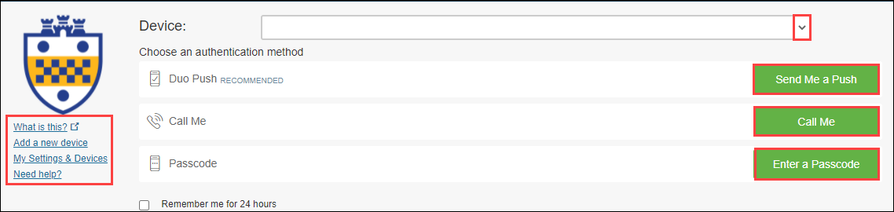
Once you have authenticated through Pitt Passport, the University of Pittsburgh Submit My Vaccine Card form will open.
In the General Information section, your Pitt Username, Contact Name, your Pitt Email Address and Phone number should auto-populate based on your Pitt login. However, if any field does not auto-populate, please input the required information manually.
NOTE: Please use your official Pitt Email Address and not an alias email address.
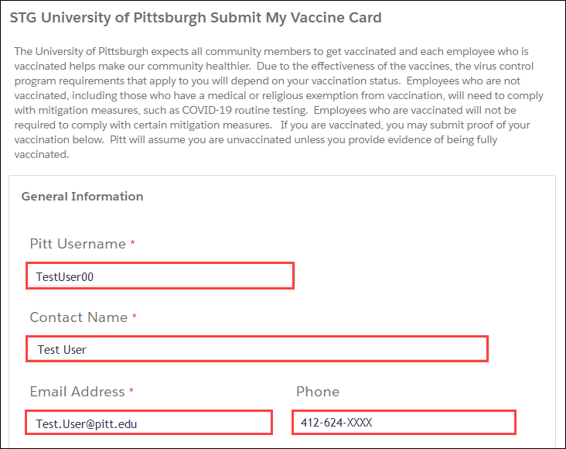
In the Vaccine Information section, select the drop-down arrow for the Name of Vaccine Dose 1 field to select the vaccine manufacturer’s name listed on your CDC COVID-19 Vaccination Record Card provided to you at the time of your first dose.
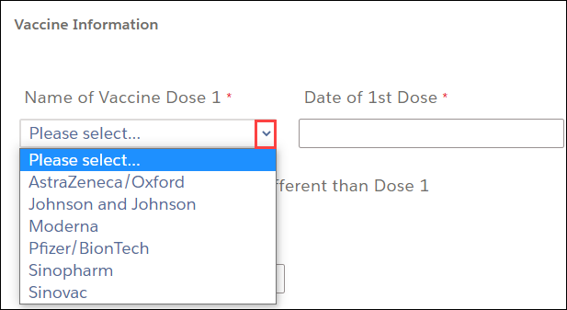
Select the Date of 1st Dose field to display a calendar.
Navigate to the month of your first COVID-19 vaccination dose by selecting the left or right arrows.
Then select the day of the month of your first dose. The month, day and year you selected will appear in the Date of 1st Dose field.
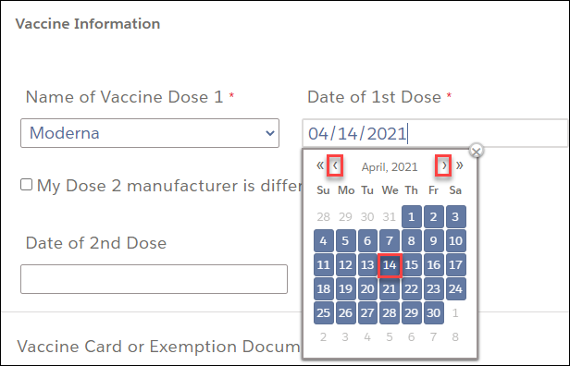
NOTE: If the manufacturer of your second dose is the same as the manufacturer of your first dose, skip this step.
If the vaccine manufacturer for your second dose is different from the manufacturer of your first dose, select the checkbox next to “My Dose 2 manufacturer is different than Dose 1” to display the Name of Vaccine Dose 2 field. Select the vaccine manufacturer’s name listed on your CDC COVID-19 Vaccination Record Card provided to you at the time of your second dose.
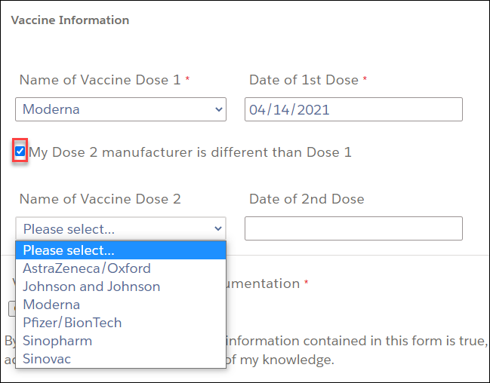
Select the Date of 2nd Dose field to display a calendar.
Navigate to the month of your second COVID-19 vaccination dose by selecting the left or right arrows.
Then select the day of the month of your second dose. The month, day, and year you selected will appear in the Date of 2nd Dose field.
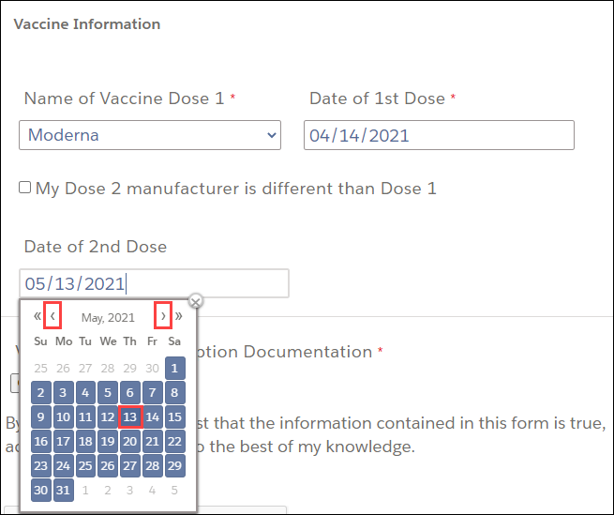

Select Choose File to upload a digital copy of your COVID-19 Vaccination Card.
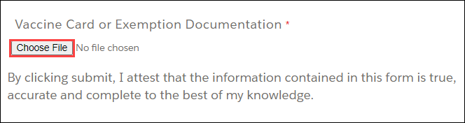
NOTE: Your experience may vary depending on the operating system you use to upload your digital copy. Please refer to the section corresponding to your device below.
Microsoft Windows Device
In the File Explorer window, navigate to the existing digital copy of your Vaccine Card and then select open.
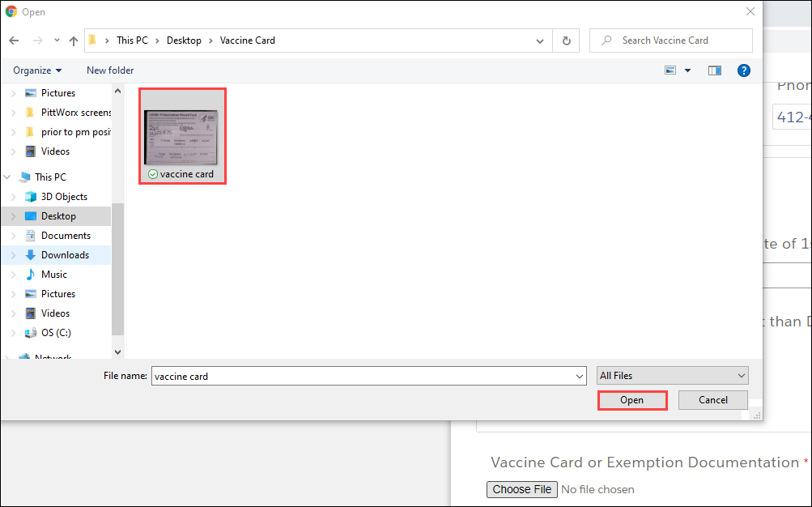

Android Device
One of two options can be selected:
- Select Camera to take a photo of your Vaccine Card using your Android device.
- Select Files to upload an existing photo of your Vaccine Card on your Android device.
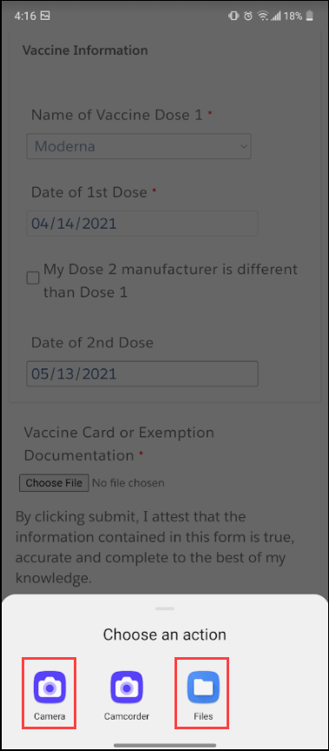

Mac iOS Device
In the File Explorer window, navigate to the existing digital copy of your Vaccine Card and then select open.
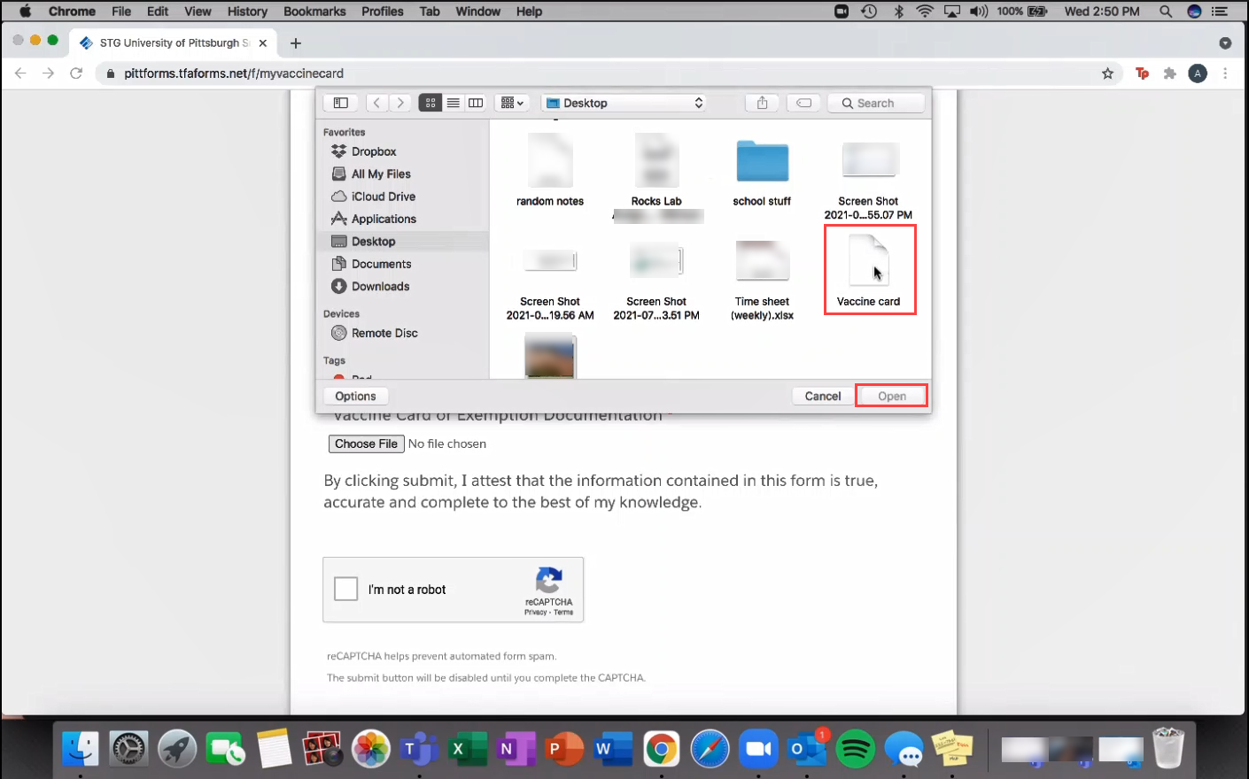

iPhone iOS Device
One of these three options may be selected:
- Select Photo Library to upload an existing photo of your Vaccine Card on your iPhone device
- Select Take Photo to take a photo of your Vaccine Card using your iPhone device
- Select Browse to upload an existing image file of your Vaccine Card on your iPhone device
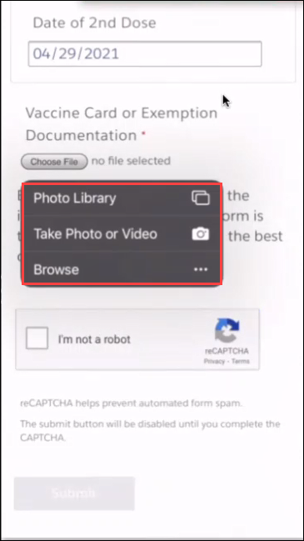

Once you have uploaded the digital copy of your Vaccine Card, select the check box next to “I’m not a robot.”
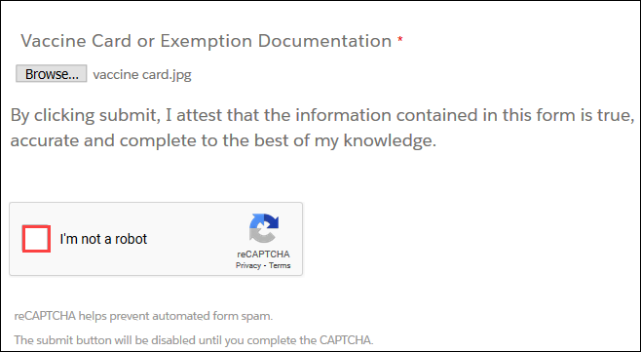
Select Submit to verify your input and confirm the statement “By clicking submit, I attest that the information contained in this form is true, accurate and complete to the best of my knowledge.”
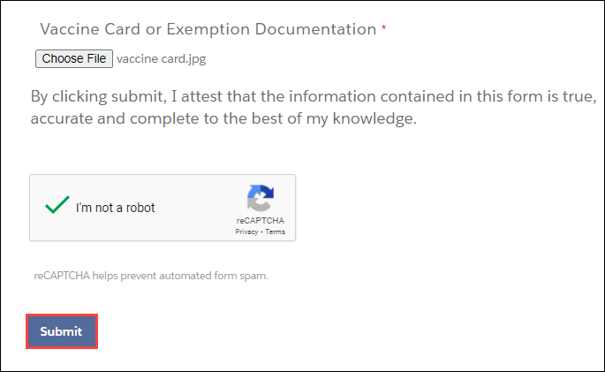
A confirmation message will be displayed.

